**DAILY ONLINE ACTIVITIES SUMMARY**

|  |  |  |  |  |  |  |  |  |
| --- | --- | --- | --- | --- | --- | --- | --- | --- |
| **Date:** | **11/06/2020** | | | | | **Name:** | **Shailashree** | |
| **Sem & Sec** | **IV sem & B section** | | | | | **USN:** | **4AL18CS077** | |
| **Online Test Summary** | | | | | | | | |
| **Subject** | | **-** | | | | | | |
| **Max. Marks** | | **30** | | **Score** | | | **-** | |
| **Certification Course Summary** | | | | | | | | |
| **Course** | **Introduction to Ethical Hacking** | | | | | | | |
| **Certificate Provider** | | | **Great learning academy** | | **Duration** | | | **4.0 hours** |
| **Coding Challenges** | | | | | | | | |
| **Problem Statement1:** Write a Java Program to Segregate Even and Odd numbers. | | | | | | | | |
| **Status: Executed** | | | | | | | | |
| **Uploaded the report in GitHub** | | | | | **YES** | | | |
| **If yes Repository name** | | | | | **Online-coding**  **https://github.com/shreee18shaila2000/Lockdown-Coding** | | | |
| **Uploaded the report in slack** | | | | | **YES** | | | |

Online Test Summary: No internals conducted today.

Online Certification Course Summary: Today I have enrolled for the new certification course that is Introduction to Ethical Hacking. In today’s session I have learnt about the Career and Growth Ladder in Ethical Hacking and also about Domains and Process Implementation under Ethical Hacking.

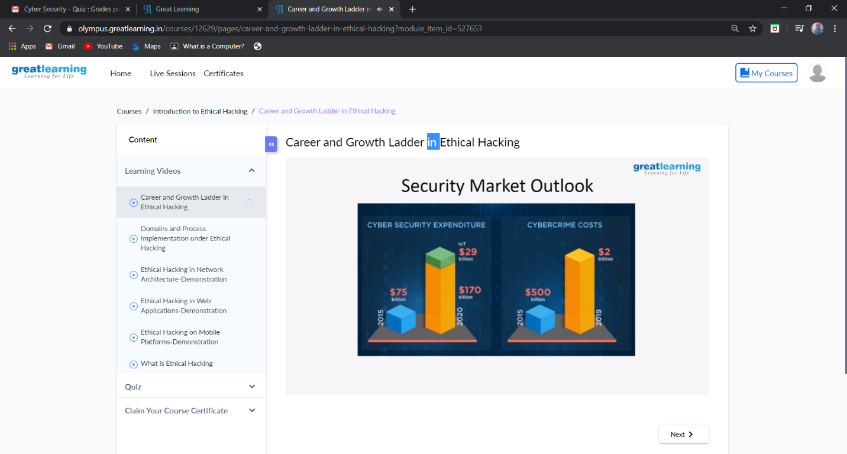

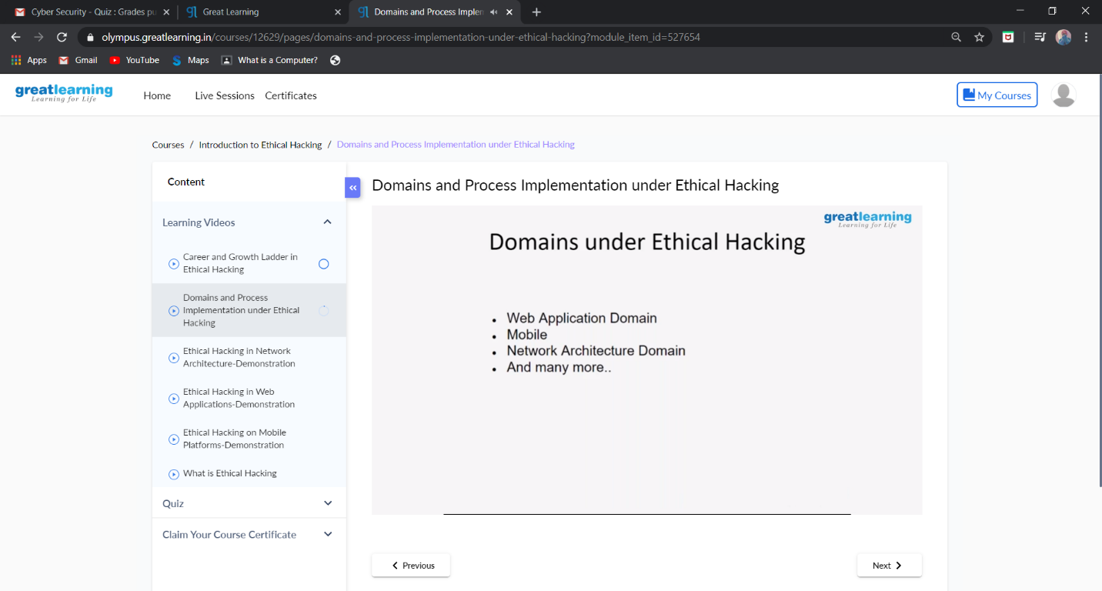

These are the snap shots of today’s sessions.

I attended the Webinar on YouTube about “BRAIN CONTROLLED ROBAT DESIGN” on 6th June 2020 Hosted by NITK-STEP in Association with PANTECH.

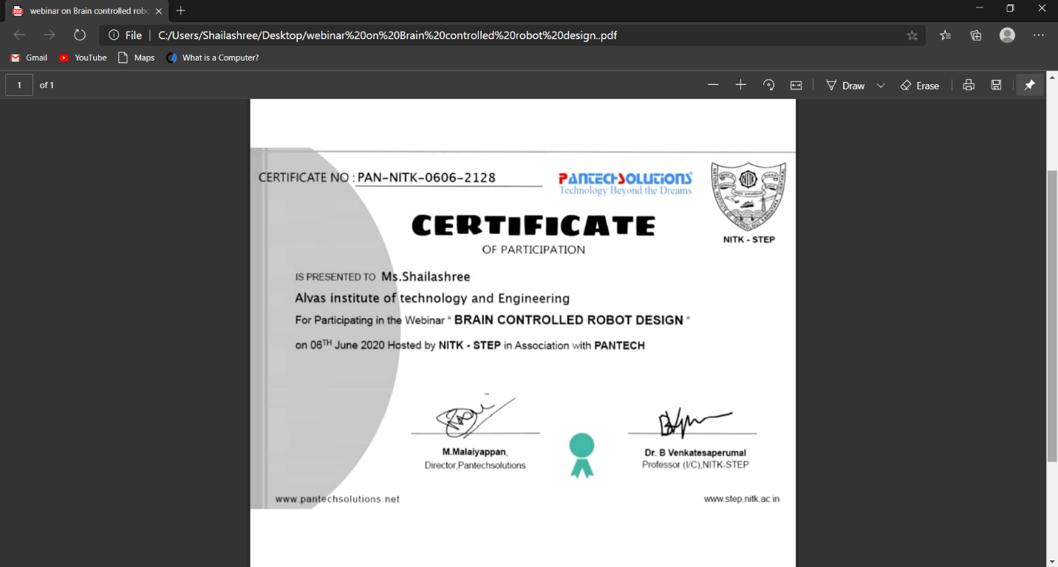

This the Screen-shot of the certificate for participation.

Online Coding Summary: **Today I had received one program from prof. Shilpa CSE Dept. The program is mentioned above in the coding challenges(pg.01). I have also uploaded it to my GitHub repository.**

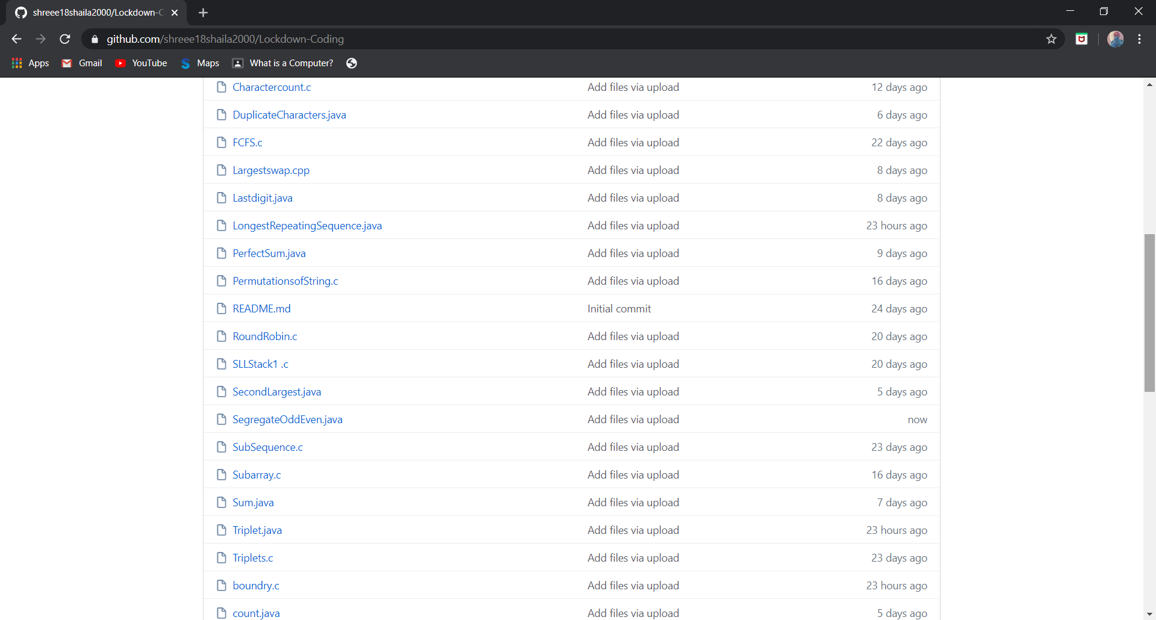

It is the snap shot of my repository were I have uploaded the code. File name is SegregateOddEven.java